Maths
Intent
Mathematics is a creative and highly inter-connected discipline that has been developed over centuries, providing the solution to some of history’s most intriguing problems. It is essential to everyday life, critical to science, technology and engineering and necessary for financial literacy. A sound knowledge and understanding of mathematics is vital for young people seeking employment and securing a qualification in mathematics is a fundamental requirement for the majority of employers. A high-quality maths education therefore provides a foundation for understanding the world and is a cornerstone in providing young people with opportunities. It should develop the ability to reason mathematically, an appreciation of the beauty and power of maths and a sense of enjoyment, confidence and curiosity about the subject.
In line with the National Curriculum Objectives for Mathematics, our intent is that all pupils:
- Become fluent in the fundamentals of mathematics, including through varied and frequent practice with increasingly complex problems over time, so that pupils have conceptual understanding and the ability to recall and apply knowledge rapidly and accurately.
- Reason mathematically by following a line of enquiry, conjecturing relationships and generalisations, and developing and argument, justification or proof using mathematical language.
- Can solve problems by applying their mathematics to a variety of routine and non-routine problems with increasing sophistication, including breaking down problems into a series of simpler steps and persevering in seeking solutions.
Mathematics is an interconnected subject in which pupils need to be able to move fluently between representations of mathematical ideas. Pupils should make rich connections across mathematical ideas to develop fluency, mathematical reasoning and competence in solving increasingly sophisticated problems. They should also apply their mathematical knowledge to science and other subjects across the curriculum.
Central to our approach are the 5 Big Ideas which underpin mastery in mathematics.
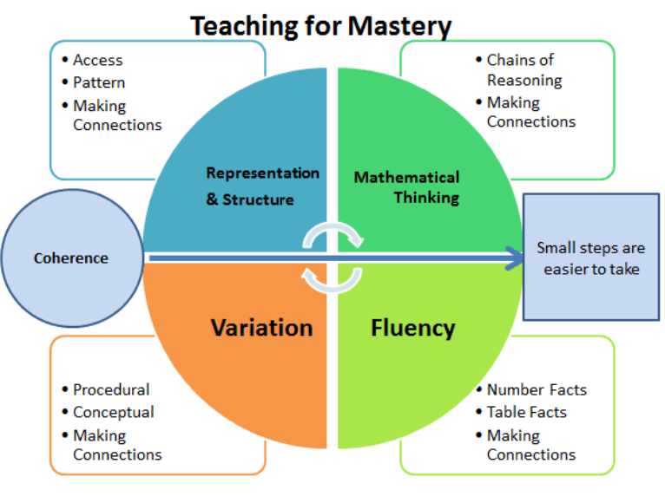
It is our intent that through the learning of mathematics, children are able to develop and demonstrate the core values of our school (Perseverance, Respect, Friendship, Compassion). In particular, the maths curriculum is designed to challenge children and encourage them to demonstrate perseverance when tackling new learning and to develop this when practising skills in solving more complex problems, whilst being supported through the use of a small steps approach which breaks the learning into small, achievable steps. Our curriculum is designed with the intent that children will develop skills in explaining mathematical reasoning and in doing so show these core values by working collaboratively with others and listening and responding to the ideas of their peers in a way which demonstrates respect, friendship and compassion
Implementation
At Sutton on the Forest children study mathematics daily following the White Rose Maths scheme of learning (WRM). WRM is a blocked scheme, which allows for depth and breadth of learning within each strand of mathematics, using a mastery approach. Maths Curriculum 2026 -2028
Hallmarks of our Mastery Approach
- Concrete, Pictorial and Abstract Learning: Children engage with a wide a varied range of concrete manipulatives, pictorial representations and abstract methodologies in their maths lessons. Manipulatives are used by all children of all ages in the school and are a fundamental part of our mastery approach. Concrete and pictorial references scaffold and strengthen understanding and are widely used as a teaching and learning tool from Foundation Stage to Year 6.
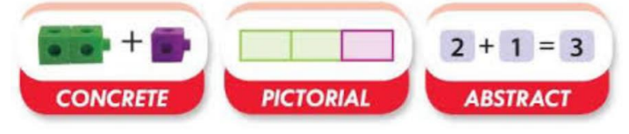
- Fluency, Reasoning and Problem Solving: Learning sessions include the opportunity to develop fluency skills, construct chains of reasoning using relevant knowledge alongside relevant terminology and solve increasingly complex problems in a systematic and coherent way.
- Mathematical Vocabulary: Sessions include explicit reference to vital mathematical vocabulary and the use of stem sentences to support and encourage all children to communicate their ideas with mathematical precision and clarity. These sentence structures often express key conceptual ideas or generalities and provide a framework to embed conceptual knowledge and build understanding.
- Interleaved learning: We want to ensure that children have the opportunity to revisit and consolidate prior learning as this has a significant positive impact on learning retention. WRM is a blocked learning scheme and as a consequence certain strands of maths are not covered until later in the school year or are not explicitly revisited. To ensure frequent revisiting of concepts, the WRM scheme is designed to ensure that prior concepts are combined in existing blocks through the design of questions and problems.
For example, questions are designed to use prior learning of money, fractions, measurement alongside current learning as shown in the below example which draws on prior learning of measurement whilst learning skills of multiplying by 100.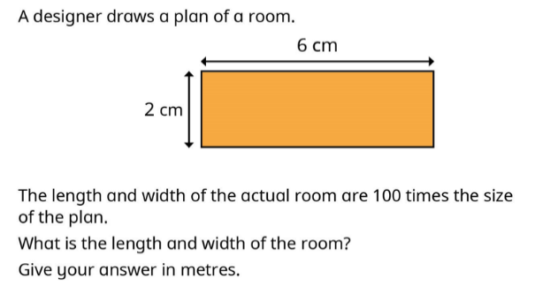
To further support children to revisit and consolidate prior learning, we also use the WRM Flashback 4 resources which provide children with practice activities taken from recent learning as well as learning from previous topics. 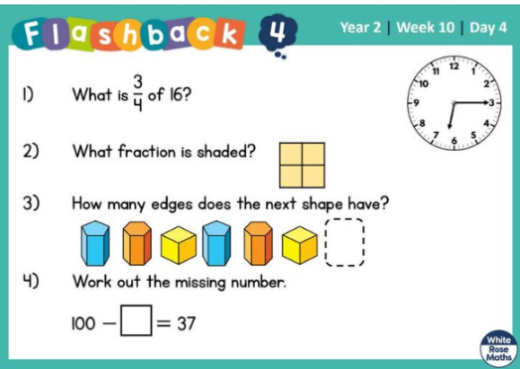
- Fluent Recall: We are committed to ensuring that pupils secure their knowledge of Times Tables by the end of Year 4. Our pupils take part in regular practise and low stakes testing through the use of Times Tables Rock Stars to practise fluent recall. We are also focussed on developing secure knowledge and recall of key number facts and children in all classes are provided with regular opportunities to practise and develop fluent recall of these number facts through the use of hands on activities, games, fluency practice and the use of the Maths Shed and/ or One Minute maths.
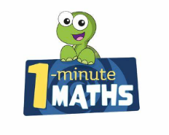

EYFS at Sutton on the Forest
We understand the importance of early experiences of maths and follow the Mastering Number and WRM schemes in our Early Year classroom which are aligned to the Early Learning Goals. This approach places a significant emphasis on developing a strong grounding in number – understanding that this is a necessary building block for children to excel in the subject.
Concrete manipulatives are a key focus within sessions, as is the use of pictorial representations including Tens Frames and Part/Whole Models. Children are actively encouraged to use mathematical terminology within their understanding, with a focus on developing positive attitudes and interest in the subject and opportunities to develop their mathematical understanding are embedded within the provision provided in the EYFS classroom and outdoor areas.

Inclusive curriculum
At Sutton on the Forest we are committed to ensuring our maths curriculum is inclusive to all children. We use key strategies of quality first teaching across the curriculum to ensure that all lessons are planned and delivered in a way that is most accessible to all children.
In maths, we use a mastery approach which is based on the premise that, wherever possible, the whole class will work together on a particular area of learning, rather than using differentiated tasks or questions. Instead of differentiating through task teachers ensure that learning is accessible and inclusive for all through use of scaffolding, focussed group support, pre-teaching or additional opportunities to practise or through in-depth questioning and problem solving to challenge children that are ready for this. This is valuable in ensuring increased self esteem and confidence in maths learning. However, when planning lessons, teachers reflect on children’s individual prior learning and targets. This process may demonstrate that a child does not yet have the foundational skills needed to access planned work alongside their peers. In instances such as this, lessons are planned to ensure they are working on the same area of maths but adapted where necessary to address and build on gaps in their foundational knowledge.
Concrete resources are routinely made available to and used by all children in the class.
A culture whereby mistakes are embraced and viewed as learning opportunities is important for our curriculum delivery and supports development of resilience and confidence for all learners.
Vocabulary is explicitly taught, explained and re-visited. Actions or visuals are also used to help to develop understanding of new words. Vocabulary is displayed in classrooms on working walls to support learners.
For children with difficulties in literacy, support is given to read and understand problems and questions, for example through use of a reader or through pictorial representations of questions. Teachers ensure that questions are set out in a way that does not overwhelm children.
Teachers and staff use live marking and feedback in lessons. This is important to reassure children they are on the right track and develop their confidence. It also ensures that misconceptions and difficulties are identified quickly and can be immediately addressed.

Enrichment
Our approach to teaching mathematics includes the provision of enrichment opportunities for our children to develop their maths learning as well as developing curiosity and an enjoyment of maths. We therefore look for opportunities to provide enrichment days or activities for our children such as Maths Rockstar Days, Barvember challenges and extra-curricular clubs.

Impact
At Sutton on the Forest, we aim for each child to be confident in each yearly objective and develop their ability to use the knowledge to develop a greater depth understanding to solve varied fluency problems and well as problem solving and reasoning questions. However, decisions about when to progress should always be based on the security of pupils’ understanding and their readiness to progress to the next stage. Pupils who grasp concepts rapidly are challenged through rich and sophisticated problems and in depth, higher level questioning before any acceleration through new content. Those who are not sufficiently fluent with earlier material consolidate their understanding through additional practice before moving on.
Formative Assessment: Teachers carry out formative assessment through assessment for learning in each session and feedback is given to children verbally, through live marking and/ or through self assessment. Teachers use this assessment to influence their planning of each session. Children are rapidly identified as needing further support or additional challenge and we work to ensure this is provided in a timely manner.
Timely interventions: Teachers have high expectations and believe that all children can succeed in maths. Children are taught in mixed ability groups using a whole class teaching approach. Children identified as needing extra support are given support through targeted booster/ pre-teaching sessions in a timely manner to ensure they are ready to move on to the next learning step alongside their peers.
Low Stakes Quizzing and Fluent Recall: We use a range of low stakes quizzes and activities throughout the teaching cycle to assess attainment and progress. These include arithmetic and times tables practice questions and are used to inform planning and to identify and address misconceptions.
Summative Assessments: Children complete the WRM end of block assessments for each phase of learning. In addition, children complete a termly summative assessment using the WRM materials which includes both arithmetic and reasoning and problem solving questions. Results are used to inform planning and allow for tailored interventions where needed.
Subject Monitoring: We monitor the quality and impact of our mathematics curriculum through targeted learning walks, book looks and pupil voice interviews. We use information gathered from these activities to inform future planning and identify and address staff CPD needs.

