Maths
Intent
At Sutton on the Forest CE Primary School, we believe that mathematics is an essential life skill and a powerful tool for understanding and making sense of the world. We want all children to develop a positive and confident attitude towards mathematics and to see themselves as capable mathematicians who are willing to explore, question, reason and persevere.
Our mathematics curriculum is ambitious and designed to ensure that all pupils develop secure, connected and increasingly sophisticated mathematical knowledge and understanding. In line with the aims of the National Curriculum, we intend for all pupils to:
· Become fluent in the fundamentals of mathematics through varied and frequent practice, developing conceptual understanding alongside the ability to recall and apply knowledge accurately and efficiently.
· Reason mathematically by exploring patterns and relationships, making conjectures and generalisations, and explaining and justifying their thinking using precise mathematical language.
· Solve problems by applying their mathematical knowledge to a range of routine and non-routine problems, selecting appropriate strategies and persevering when solutions are not immediately apparent.
We recognise mathematics as an interconnected subject. Our curriculum is designed to help pupils make meaningful connections between mathematical ideas, move fluently between different representations and build upon prior learning so that knowledge becomes increasingly secure over time.
Central to our approach are the 5 Big Ideas of mastery in mathematics: coherence, representation and structure, mathematical thinking, fluency and variation. We aim to develop deep and lasting understanding rather than simply procedural knowledge.
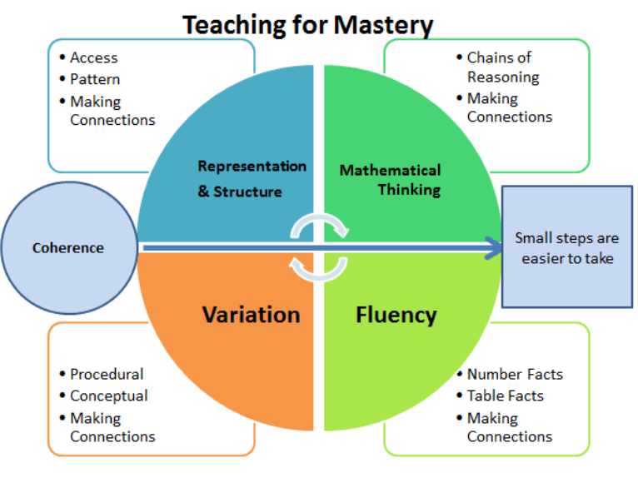
Mathematics also provides opportunities for children to develop our school values of Perseverance, Respect, Friendship and Compassion. Children are encouraged to embrace challenge and learn from mistakes, share and explain their thinking, listen to the ideas of others and work collaboratively.
Ultimately, we want every child to leave Sutton on the Forest with a secure foundation in mathematics, confidence in their own ability and the knowledge, skills and attitudes needed to succeed at the next stage of their education and beyond.
Implementation

Mathematics is taught daily through a carefully sequenced curriculum that builds knowledge progressively and provides regular opportunities for pupils to revisit and consolidate previous learning.

Curriculum Planning and Progression

In EYFS, we use Mastering Number to develop a strong foundation in number, alongside White Rose Maths to support wider mathematical learning. Mathematical understanding is developed through adult-led teaching and purposeful opportunities within continuous provision, both indoors and outdoors. Ongoing assessment is used to identify and address gaps in children's early mathematical knowledge.

In Year 1, we use Mastering Number alongside White Rose Maths planning, supporting the continued development of strong number sense, fluency and confidence.

Across Key Stage 1, teaching follows White Rose Maths planning. Across Key Stage 2, teaching follows the updated White Rose Mixed-Age planning, providing a coherent framework for our mixed-age classes.

White Rose planning provides the structure for our curriculum; however, teachers use ongoing assessment and professional judgement to adapt the pace of learning where necessary. Pupils may require longer to develop secure understanding of a concept, while curriculum coverage is monitored to ensure that any missed learning is revisited or completed.

Teaching for Mastery

Our teaching is underpinned by a mastery approach. Wherever possible, pupils work together on the same key mathematical concepts, with support and challenge adapted to ensure that all children can access and make progress in their learning.

Learning is broken down into carefully sequenced small steps, enabling pupils to build new knowledge on secure prior understanding. We use a Concrete, Pictorial and Abstract (CPA) approach, with manipulatives and representations available to support and deepen understanding from EYFS to Year 6.

Pupils who need additional support, including those with SEND or gaps in prior learning, may receive additional teaching, pre-teaching, targeted practice and adapted resources. Where significant gaps in foundational knowledge are identified, teaching may draw upon earlier stages of the mathematics curriculum to help pupils build the essential knowledge needed for future learning.

Pupils who demonstrate secure understanding are challenged through deeper thinking, rich problems, in-depth questioning and appropriate stretch within both teacher input and tasks. White Rose Fluency, Stretch and Challenge resources, alongside other appropriate materials, are used to promote depth and increasing independence.

Fluency, Reasoning and Problem Solving

Mathematics lessons provide regular opportunities for pupils to develop fluency, reasoning and problem-solving skills.

Children develop fluency through purposeful practice and the secure recall and application of key mathematical knowledge and facts. They develop reasoning by explaining their thinking, identifying patterns and relationships, making generalisations and justifying their answers. They develop problem-solving skills by applying their mathematical knowledge to increasingly complex and unfamiliar situations and selecting appropriate strategies.

Mathematical vocabulary is explicitly taught, modelled and revisited. Teachers use precise mathematical language and stem sentences where appropriate to help pupils communicate their thinking with clarity and accuracy.

Retrieval and Fluent Recall

Regular retrieval helps pupils retain, consolidate and connect their mathematical knowledge. Although White Rose Maths is organised into blocks of learning, pupils are given opportunities to revisit previous concepts and apply earlier learning within new contexts.

We use White Rose Flashback 4 and Vocabulary Ninja Fluent Five activities to support the retrieval and consolidation of recent and previously taught learning.

Children are also provided with regular opportunities to develop fluent recall of key number facts through practical activities, games and fluency practice, including the use of Maths Shed and/or One Minute Maths. A particular focus is placed on securing multiplication tables knowledge by the end of Year 4, supported through regular practice and low-stakes assessment, including Times Tables Rock Stars.

Inclusive Practice and Assessment

We are committed to ensuring that all children can access and succeed in mathematics. Teachers carefully consider pupils' prior learning and use appropriate scaffolding, representations, questioning and adaptations to reduce barriers to learning.

A range of resources may be used to provide additional support, practice and challenge, including White Rose resources, Testbase, Classroom Secrets, Twinkl and Grammarsaurus.

Assessment is an integral part of mathematics teaching. Teachers use questioning, observation, discussion, pupils' work and live feedback to identify understanding and misconceptions and adapt teaching accordingly. Pupils complete appropriate White Rose end-of-block and termly assessments, including arithmetic, reasoning and problem-solving. Assessment materials may be adapted where necessary to reflect pupils' learning and stage of understanding.
Impact
The impact of our mathematics curriculum is seen in pupils who develop secure, connected and increasingly sophisticated mathematical knowledge as they progress through the school.
We want children at Sutton on the Forest to become confident and resilient mathematicians who:
· demonstrate secure understanding of the mathematical knowledge appropriate to their stage of learning;
· develop increasing fluency and recall and apply key facts, concepts and procedures accurately and efficiently;
· move flexibly between concrete, pictorial and abstract representations;
· use precise mathematical vocabulary to explain, reason and justify their thinking;
· recognise patterns, make connections and apply previous learning to new situations;
· approach routine and non-routine problems with confidence, selecting appropriate strategies and persevering when faced with challenge;
· demonstrate increasing independence and confidence in their mathematical learning;
· recognise mistakes as an important part of learning and respond positively to challenge and feedback.
Pupils progress through the curriculum based on the security of their understanding and readiness to move forward. Those who demonstrate secure understanding are challenged through deeper thinking and rich problems, while pupils who require further support or additional time are given opportunities to consolidate essential knowledge and address misconceptions.
The impact of our curriculum is monitored through formative and summative assessment, low-stakes assessment of key facts and multiplication tables, scrutiny of pupils' work, pupil voice, lesson visits and subject monitoring. This evidence is used to identify strengths and areas for development and to inform future teaching, intervention and professional development.
Ultimately, children leave Sutton on the Forest with the mathematical knowledge, fluency, reasoning and problem-solving skills needed to succeed at the next stage of their education. They leave with confidence in their ability as mathematicians and an understanding of the value, relevance and enjoyment of mathematics.

