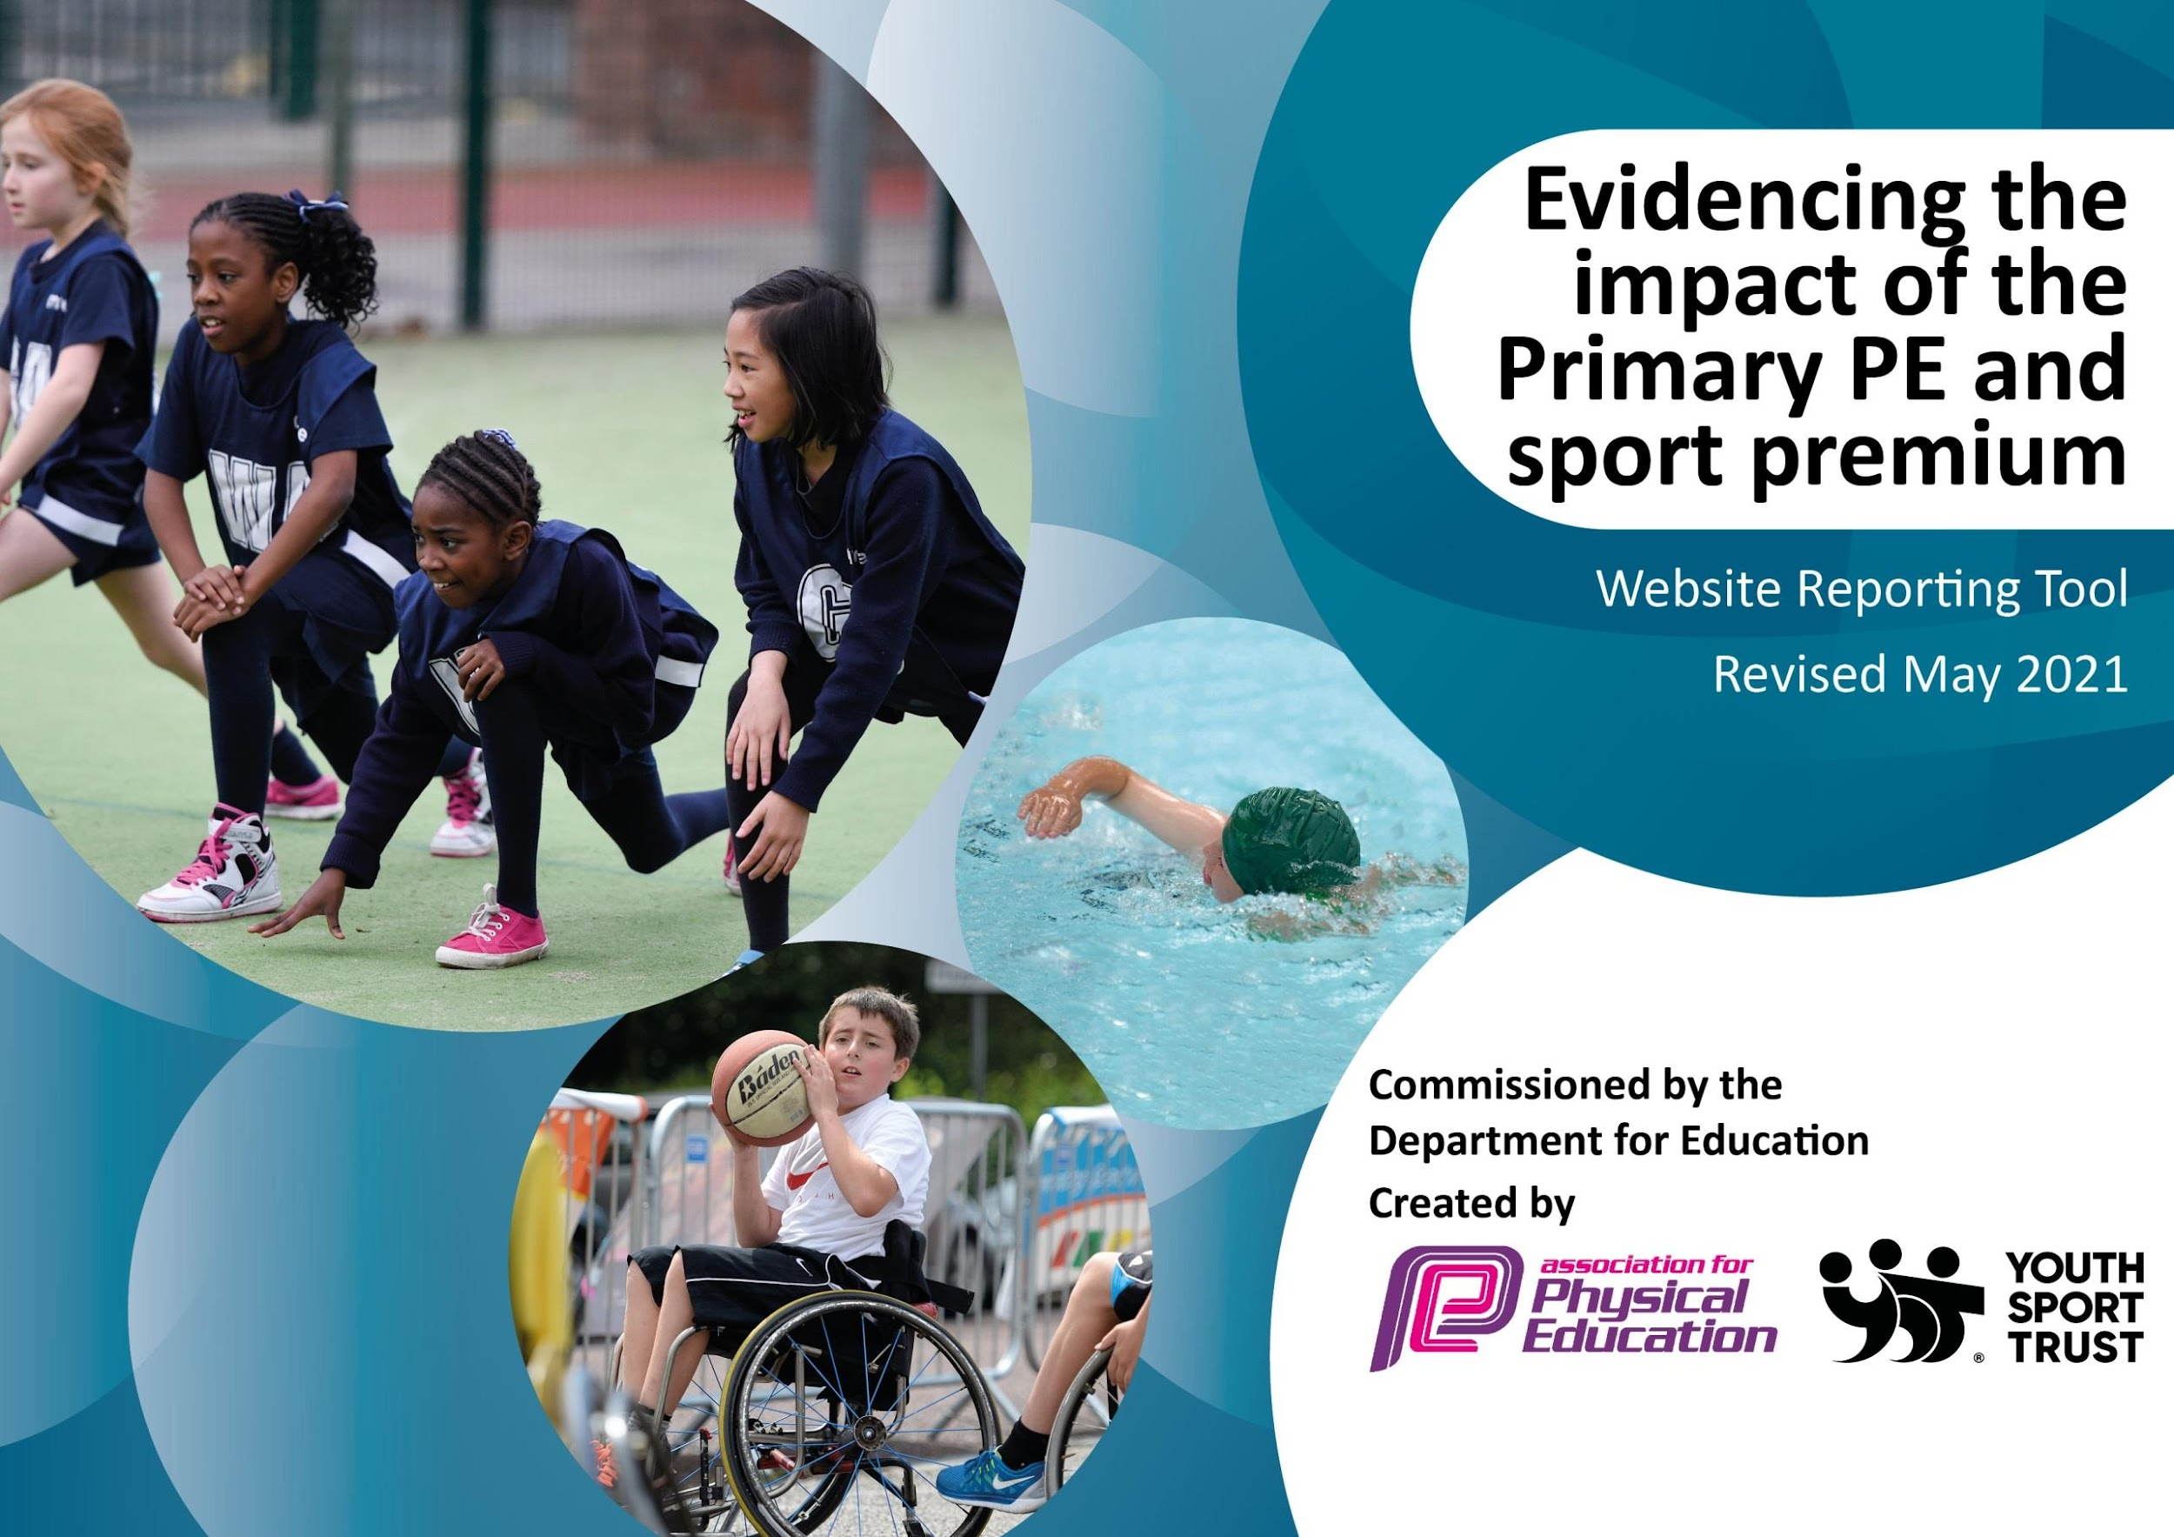

It is important that your grant is used effectively and based on school need. The Education Inspection Framework (Ofsted 2019 p64) makes clear there will be a focus on ‘whether leaders and those responsible for governors all understand their respective roles and perform these in a way that enhances the effectiveness of the school’.

Under the Quality of Education criteria (p41) inspectors consider the extent to which schools can articulate their curriculum (INTENT), construct their curriculum (IMPLEMENTATION) and demonstrate the outcomes which result (IMPACT).

To assist schools with common transferable language this template has been developed to utilise the same three headings which should make your plans easily transferable between working documents.

Schools must use the funding to make additional and sustainable improvements to the quality of Physical Education, School Sport and Physical Activity (PESSPA) they offer. This means that you should use the Primary PE and sport premium to:

- Develop or add to the PESSPA activities that your school already offer
- Build capacity and capability within the school to ensure that improvements made now will benefit pupils joining the school in future years
- The Primary PE and sport premium should not be used to fund capital spend projects; the school’s budget should fund these.
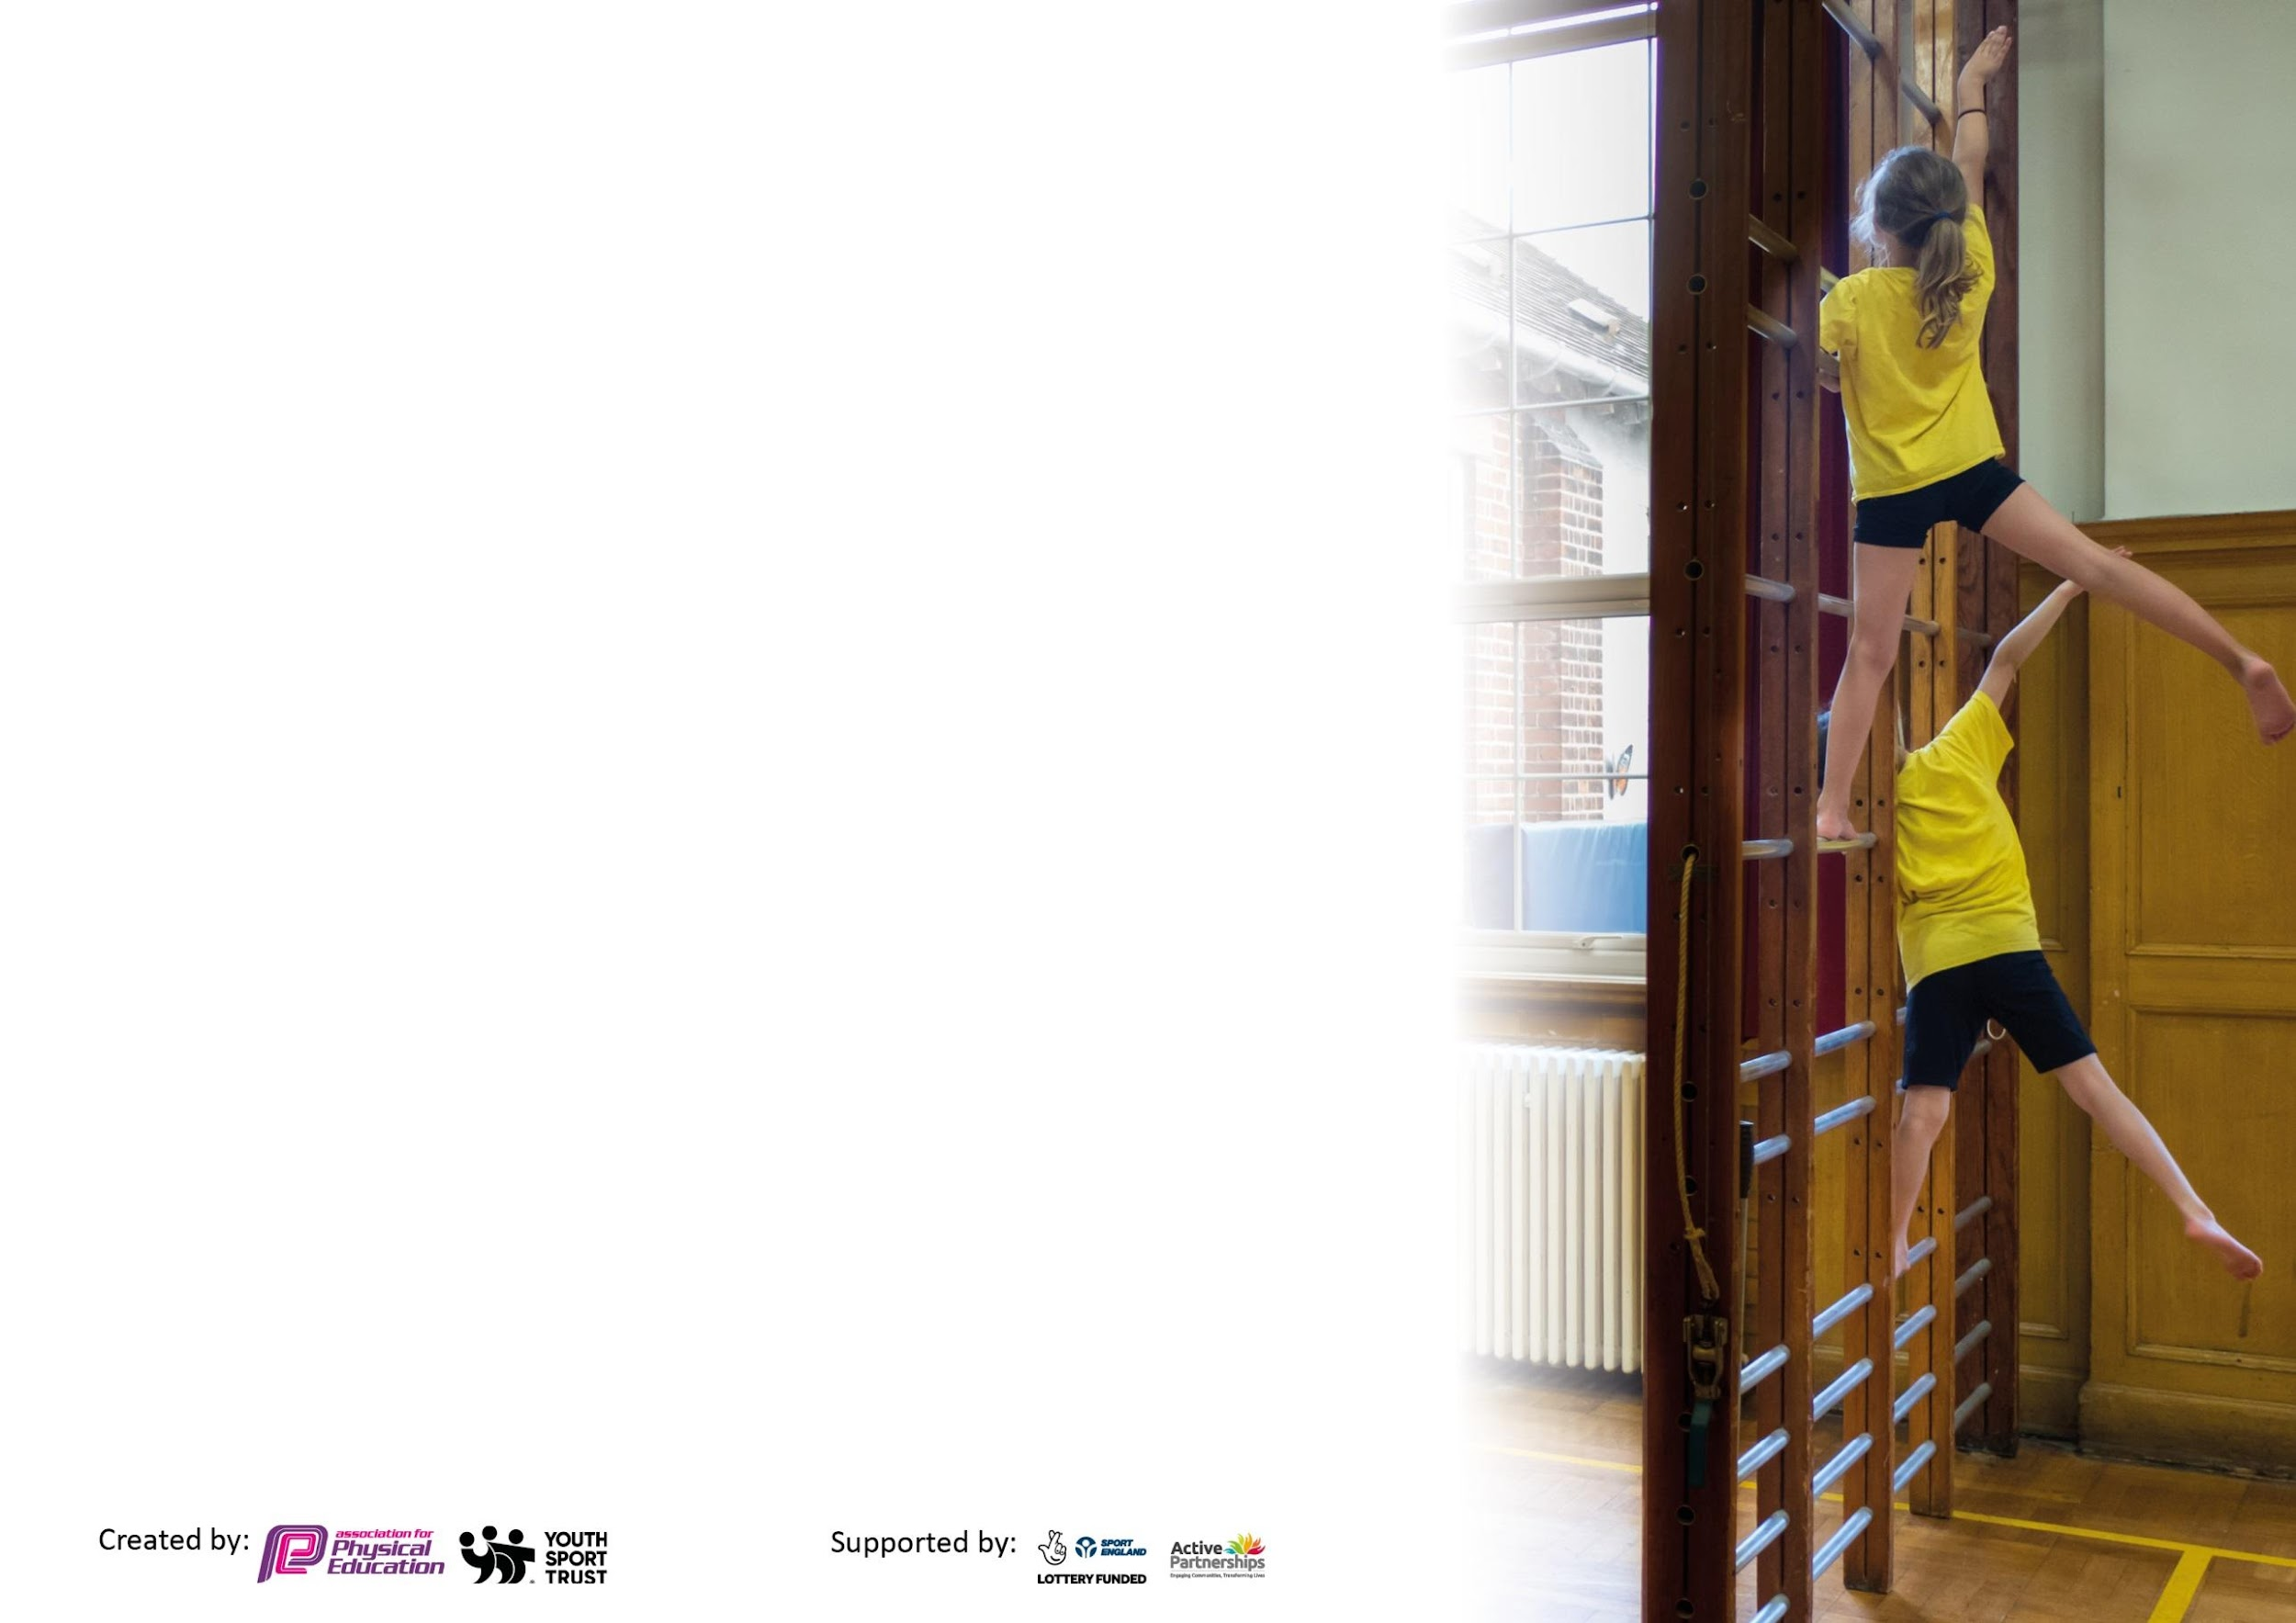
Please visit gov.uk for the revised DfE guidance including the 5 key indicators across which schools should demonstrate an improvement. This document will help you to review your provision and to report your spend. DfE encourages schools to use this template as an effective way of meeting the reporting requirements of the Primary PE and sport premium.

We recommend you start by reflecting on the impact of current provision and reviewing the previous spend.

Schools are required to publish details of how they spend this funding, including any under-spend from 2019/2020, as well as on the impact it has on pupils’ PE and sport participation and attainment by the end of the summer term or by 31st July 2021 at the latest.

We recommend regularly updating the table and publishing it on your website throughout the year. This evidences your ongoing self-evaluation of how you are using the funding to secure maximum, sustainable impact. Final copy must be posted on your website by the end of the academic year and no later than the 31st July 2021. To see an example of how to complete the table please click HERE.

Please note: Although there has been considerable disruption in 2020 it is important that you publish details on your website of how you spend the funding - this is a legal requirement.

Support for review and reflection - considering the 5 key indicators from DfE, what development needs are a priority for your setting and your pupils now and why? Use the space below to reflect on previous spend and key achievements and areas for development.

N.B. In this section you should refer to any adjustments you might have made due to Covid-19 and how these will influence further improvement.
Key achievements to date until July 2021: |  | Areas for further improvement and baseline evidence of need:
Improved pupils’ participation in the School Games (Gold award received)  - Entered more cluster sport competitions (Inter-school)  - Provided sporting activities for children at our small, rural school.  - Raised the profile of sport and active lifestyle.  - Encourage leadership, timekeeping and officiating for KS2 pupils.  Introduced sports and activities to help pupils become more active for one off activity days or a series of high quality sessions  - Hired qualified coaches to work with teachers and pupils to extend sports provision and provide after school clubs for children including:  - Chance to Shine cricket training for all children in school.  - Hockey Heroes – City of York Hockey  - Football training with coach from York College.  - Multi-sports club for KS2 and KS1.  - Children gain valuable opportunities to lead, manage and officiate sporting activities in a range of school sports.  Achieved Healthy Schools Award Gold status  The four award themes are: Active Lifestyles, Emotional Health & Wellbeing, Food in schools and Personal, Social & Health Education. Evidence was provided to support a high level of engagement across school in all four areas |  | - Children more engaged in school sports, sports clubs are highly attended both after school and through link clubs.  - Need to focus on active travel to and from school and active teaching during class time (based on activity heat map self-evaluation review).  - We will continue to provide a range of sports and sports coaches to work with teachers and pupils to benefit their health and wellbeing.
 | Development of school’s intra-school and inter-school competition programme  - Use of Kobocca to participate in inter-school competitions and track participation  - Y5/6 Young leaders leading intra-house competitions |  | - Increased physical activity ethos around school and expectations raised that school will send teams to inter-school events in 2021-22 post-pandemic and participate in a full programme of sporting activity.  - Efficient tracking has been undertaken to ensure that all children get equal opportunities to participate in team and individual cluster sports.  - The competitions are an important part of school life and help to develop our school values of respect, compassion, friendship and perseverance.
 | Professional development in PE for staff to enable high quality PE to be taught in school  - CPD for staff (LTA Tennis, Wellbeing Champion training through Compass Buzz)  - Teaching cover for staff training. |  | - Programme of training provided by North Yorkshire sport. Courses used to further PE provision and teaching in school.  - PE network meetings attended and opportunities for further CPD utilised through this.
 | Learning resources for high quality PE sessions  - iPad lease for recording and photographing sport in PE e.g. recording pupil’s sport techniques and analyse these to further their learning and development.  - Further books purchased which promote a range of sports, active lifestyle and physical/mental wellbeing.  - Forest School equipment purchased to promote outdoor learning.  - Outdoor learning environment developed to promote physical activity for KS1 children |  | - The resources have transformed PE sessions with children being able to use outdoor space safely and productively.
 | PE lead appointed to:  - Support teachers in the delivery of quality PE and a range of sports during school, at lunchtimes and after school.  - Increased support in PE lessons, assisting in teacher confidence and ability to deliver quality first PE lessons.  - Organise and run intra school competitions to help children develop their sporting skills and promote our school values of respect, compassion, friendship and perseverance.  - Be a role model for children in school and help empower them to drive for sporting success. |  | - Sports coach has been able to upskill school staff in a range of sports and multi-skills for physical development and good physical and mental wellbeing.  - Assisting in the organisation and management of inter-school and intra-school events to promote an active lifestyle and giving children the chance to take part in regular, competitive sports.
Did you carry forward an underspend from 2019-20 academic year into the current academic year? NO
Total amount carried forward from 2019/2020 £ 0
+ Total amount for this academic year 2020/2021 £16,650
= Total to be spent by 31st July 2021 £3778

Meeting national curriculum requirements for swimming and water safety.

N.B Complete this section to your best ability. For example you might have practised safe self-rescue techniques on dry land which you can transfer to the pool when school swimming restarts.
Due to exceptional circumstances priority should be given to ensuring that pupils can perform safe self rescue even
if they do not fully meet the first two requirements of the NC programme of study.
What percentage of your current Year 6 cohort swim competently, confidently and proficiently over a distance of at least 25 metres?  N.B. Even though your pupils may swim in another year please report on their attainment on leaving primary school at the end of the summer term 2021.  Please see note above. | 94%
What percentage of your current Year 6 cohort use a range of strokes effectively [for example, front crawl, backstroke and breaststroke]?  Please see note above. | 88%
What percentage of your current Year 6 cohort perform safe self-rescue in different water-based situations? | 24%
Schools can choose to use the Primary PE and sport premium to provide additional provision for swimming but this must be for activity over and above the national curriculum requirements. Have you used it in this way? | No

Action Plan and Budget Tracking
Capture your intended annual spend against the 5 key indicators. Clarify the success criteria and evidence of impact that you intend to measure to evaluate for pupils today and for the future.

Academic Year: 2020/21 | Total fund allocated: £ | Date Updated:
Key indicator 1: The engagement of all pupils in regular physical activity – Chief Medical Officers guidelines recommend that primary school pupils undertake at least 30 minutes of physical activity a day in school |  |  |  | Percentage of total allocation:
 |  |  |  | %
Intent | Implementation |  | Impact
Your school focus should be clear what you want the pupils to know and be able to do and about  what they need to learn and to  consolidate through practice: | Make sure your actions to achieve are linked to your intentions: | Funding allocated: | Evidence of impact: what do pupils now know and what can they now do? What has changed?: | Sustainability and suggested next steps:
To increase physical activity throughout school for all children with the aim of providing at least 30 minutes of physical activity a day. | - Timetabled 2 hours of PE a week for all children in school.  Equipment purchased to improve PE equipment  - Purchased new playground and sporting equipment for all children to use in PE lessons and at break times.  - Forest School equipment (fire pit, cooking tools, ingredients) | £150  £1500  £500 | All classes are timetabled 2 hours of PE, checked by the PE lead to ensure they meet the minimum requirements of an active day.  New equipment was chosen by the pupils who have used it during their PE lessons and also in their free time to maintain an active lifestyle. | Longer term for children:  - Increase physical activity to 60 minutes a day.  - Encourage more than 50% of children to attend a school sports club each week.  Longer term for staff:  - Increase daily physical activity through self-evaluation tool Encourage the introduction of an active mile.  Next steps for the school:  - Decide on where to fit more activity into the daily school timetable and how to staff this.
To increase mental health and wellbeing for all staff and pupils | - CPD for all staff  - Paediatric first aid for mental health course  - Wellbeing resources to be used during ELSA sessions  - Jigsaw PSHE resource | £200  £350  £200  £500
Key indicator 2: The profile of PESSPA being raised across the school as a tool for whole school improvement |  |  |  | Percentage of total allocation:
 |  |  |  | %
Intent | Implementation |  | Impact
Your school focus should be clear what you want the pupils to know and be able to do and about  what they need to learn and to  consolidate through practice: | Make sure your actions to achieve are linked to your intentions: | Funding allocated: | Evidence of impact: what do pupils now know and what can they now do? What has changed?: | Sustainability and suggested next steps:
To ensure that PE lessons, physical activity and wellbeing are of high quality and that they are taught effectively as a core subject that is timetabled for maximum engagement with pupils. | - Forest School sessions taking place regularly across school by our accredited Forest Schools Leader  - The school held a mental wellbeing day during Mental Health Week, with a focus on how physical and mental wellbeing can affect our health. An active lifestyle was promoted to all children across the day.  - PE and sports books bought to promote healthy physical and mental lifestyles.  - Wellbeing Champions – trained by our Wellbeing Lead (additional hours)  - Wellbeing Lead employed two afternoons per week  - Development of outside area to promote activity and mental health and wellbeing | £2500  Resource for the day £200  £100  £260  £2144  £5000 | Children respond positively to Forest School sessions and have had ample opportunity to learn outdoors and improve both their physical and mental wellbeing.  A big, positive response from the children and parents. This is repeated annually  These have been used by teachers and pupils to promote healthy lifestyles across school, particularly in KS1 where pictures convey an age appropriate message clearly. | Longer term for children:  - To gain feedback from children about the PE sessions they want to see in school plus any feedback into what they think about PE.  - To continue to hold Forest School sessions, mental health and wellbeing days to engage all students in having an active lifestyle, raising the profile of PE in the process.  Longer term for staff:  - Ensure that all staff are confident in delivering PE following the newly implemented whole school PE scheme.  - Continue to review the effectiveness of this scheme in an annual basis.  Next steps for the school:  - To review PE provision currently in place including lessons, PE scheme and children’s attitude to PE.

Key indicator 3: Increased confidence, knowledge and skills of all staff in teaching PE and sport |  |  |  | Percentage of total allocation:
 |  |  |  | %
Intent | Implementation |  | Impact
Your school focus should be clear | Make sure your actions to | Funding | Evidence of impact: what do | Sustainability and suggested
what you want the pupils to know | achieve are linked to your | allocated: | pupils now know and what | next steps:
and be able to do and about | intentions: |  | can they now do? What has
what they need to learn and to |  |  | changed?:
consolidate through practice:
The implementation of whole school PE curriculum along with progression documents for individual sports to assist with planning, delivery, assessment and continued quality. This will support staff in delivering a high standard of PE sessions for all. This will be accompanied by CPD for teachers who require additional assistance. | - Hiring of a cricket coach/hockey coach to support teachers in the delivery of quality cricket/hockey  - PE network meetings attended by PE lead to gain insight and new information about sports programmes in the county as well as further access to PE training and opportunities.  - iPad lease used for recording and photographing sport in PE e.g. recording pupil’s sport techniques and analyse these to further their learning and development.  - Whole school PE plan created and put in place by PE lead with a variety of indoor and outdoor provision as well as sport progression documents for all to use. | See key indicator 2.  £0  £1000  £0 | Cricket coach has been able to work well with staff to support them in PE lessons and sports coaching.  PE lead has benefitted from networking at these meetings and has gained new skills and knowledge to share with the whole staff.  These resources have been essential in assisting teachers with delivering high quality PE and allowing both teachers and pupils to review their techniques as well as monitor their performance during competitive sport.  These whole school plans ensure that children build on skills across their school lifetime and become able sportsmen and sportswoman. It also helps teacher to deliver excellent PE sessions which develop key skills and good sporting techniques across all ages. | Longer term for children:  - To keep providing high quality PE sessions that are inclusive for all children.  Longer term for staff:  - To provide CPD to assist with subject knowledge and delivery of PE curriculum.  - To continue to attend PE network meetings and further enhance subject knowledge of PE and sports curriculum.  Next steps for the school:  - For SLT to support PE leads in refining PE curriculum.  - Continued PE CPD for all teachers and TAs.
Key indicator 4: Broader experience of a range of sports and activities offered to all pupils |  |  |  | Percentage of total allocation:
 |  |  |  | %
Intent | Implementation |  | Impact
Your school focus should be clear | Make sure your actions to | Funding | Evidence of impact: what do | Sustainability and suggested
what you want the pupils to know | achieve are linked to your | allocated: | pupils now know and what | next steps:
and be able to do and about | intentions: |  | can they now do? What has
what they need to learn and to |  |  | changed?:
consolidate through practice:
Develop a range of sporting opportunities for all children through sports taster days, sports coaching in school, after school activities and physical activity equipment.  Aim to have at least 3 outside providers working with the children to encourage sporting participation and active lifestyle. | 1) Hired qualified coaches to work with teachers and pupils to extend sports provision and provide after school clubs for children including:  - Circus York for all children in school.  - Chance to Shine Cricket training for all children in school.  - York City Hockey Club training for all KS2 children in school  2) Bikeability safe bike riding skills for year 6s.  3) Multi-sports club for KS2 and KS1 (including multi-skills, cricket, archery, table tennis and netball). | £150  £450  £260  £560  £0 | Excellent feedback from children and parents due to wide range of sports provided. Children in large numbers have been taking up new sports and becoming more active individuals as a result of this.  Chance to Shine Cricket was particularly well received and school became a case study for the programme.  All year 6s passed the training and instructors were impressed with their dedication and attitude.  Ensuring that a good range of sporting activities were on offer that children enjoyed, with the after school club being oversubscribed. | Longer term for children:  - Continue to expose children to a wide range of sports and activities.  - Develop an active travel programme promoting safe and active travel skills to and from school.  - Ongoing access to cluster sport competitions, training for team sports and developing sports leaders in KS2.  Longer term for staff:  - Continued professional development through sports coaches supporting and leading PE sessions.  Next steps for the school:  - A full and representative pupil voice to be collected about the provision, sports and external providers they would be interested in having in school.

Key indicator 5: Increased participation in competitive sport |  |  |  | Percentage of total allocation:
 |  |  |  | %
Intent | Implementation |  | Impact
Your school focus should be clear | Make sure your actions to | Funding | Evidence of impact: what do | Sustainability and suggested
what you want the pupils to know | achieve are linked to your | allocated: | pupils now know and what | next steps:
and be able to do and about | intentions: |  | can they now do? What has
what they need to learn and to |  |  | changed?:
consolidate through practice:
All KS2 children take part in at least 2 competitive school events across the academic year at inter-school level. KS1 to take part in at least 1 event at inter-school level. Intra-school sports events will be increased this year to at least 4 per key stage by summer 2021. | - Expanded participation in cluster sports programme of events across the school year (Easingwold cluster, Thirsk SGO district). | £2000 | Children have had the opportunity to participate virtually in different cluster events (8 KS2, 2 KS1) and have performed well , raising the profile of PE in school and encouraging healthy, active competition amongst their peers. | Longer term for children:  - Access to cluster competitions at level 1, 2 and 3 were appropriate.  - More opportunities to compete in houses across the school year.  Longer term for staff:  - Ensuring that all staff have the opportunity to organise and support the coordination of intra and inter school sporting events throughout the year.  Next steps for school:  - Consider how KS1 have can have access to a similar broad range of cluster sports as KS2 have.  - Increase number of intra school events each year by 20%

Signed off by
Head Teacher: | Helen Pye
Date: | July 2021
Subject Leader: | Helen Pye
Date: | July 2021
Governor: | FGB
Date: | July 2021

