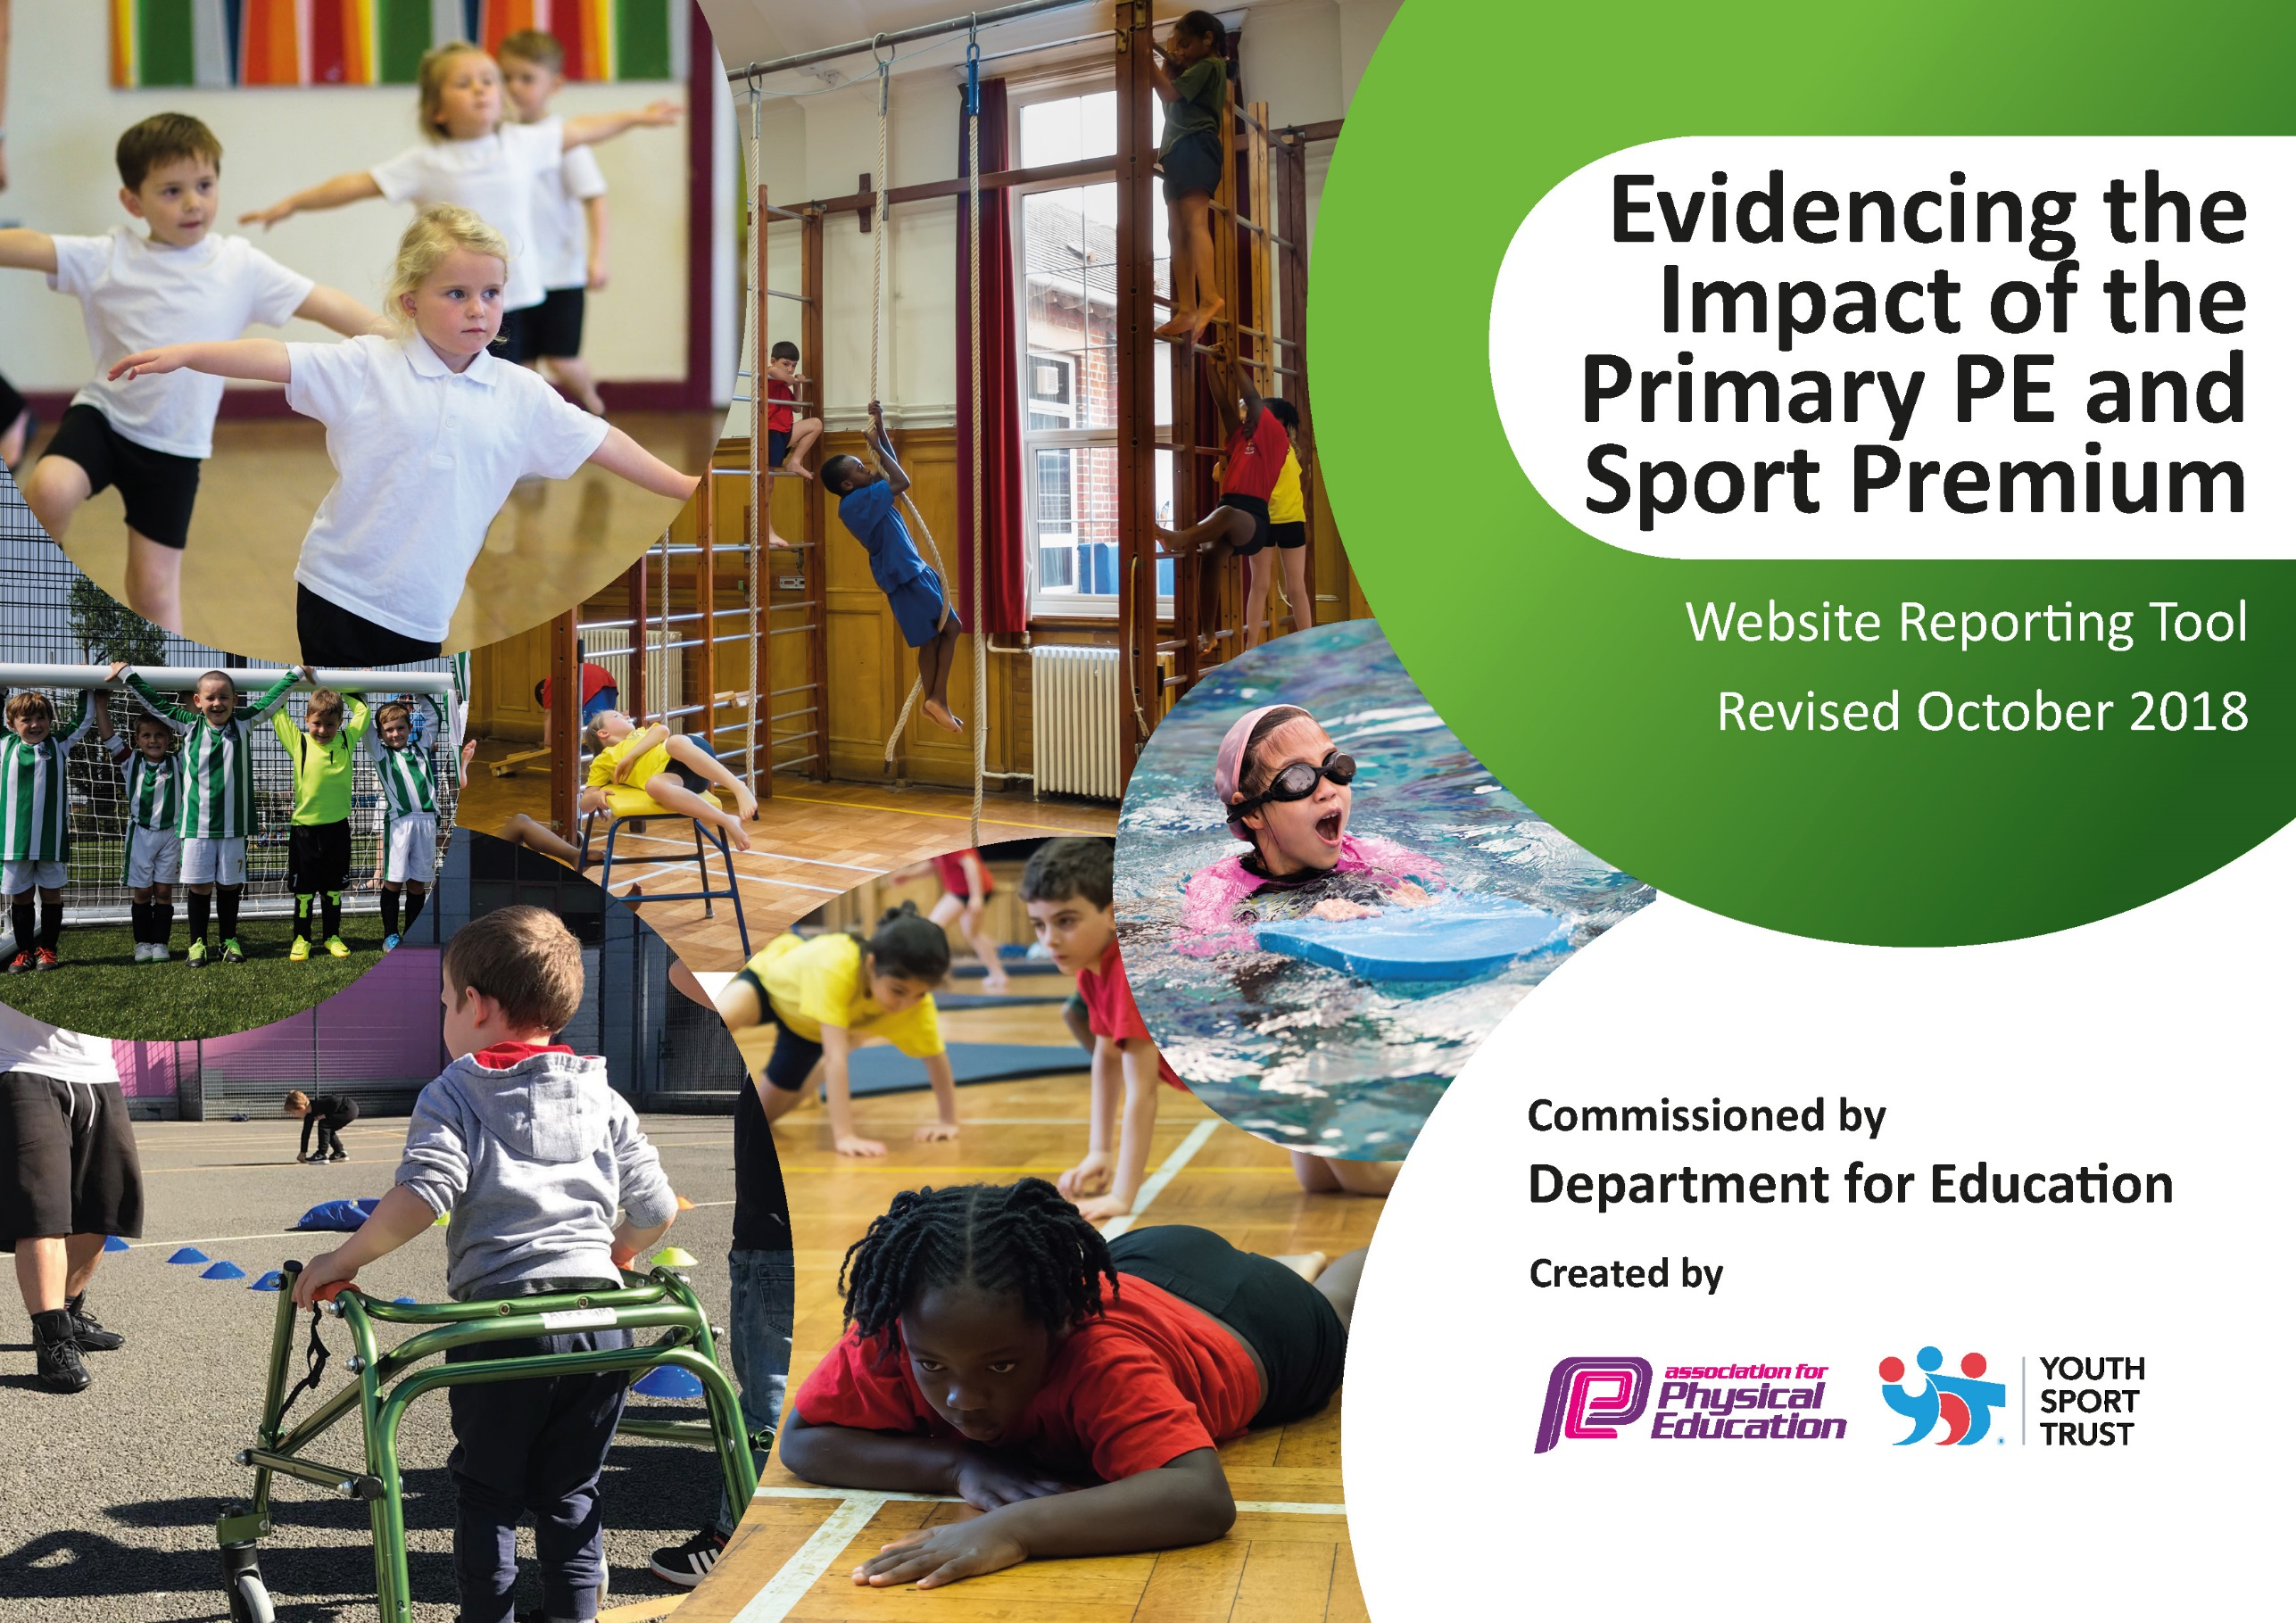
Sutton on the Forest CEVA Primary School
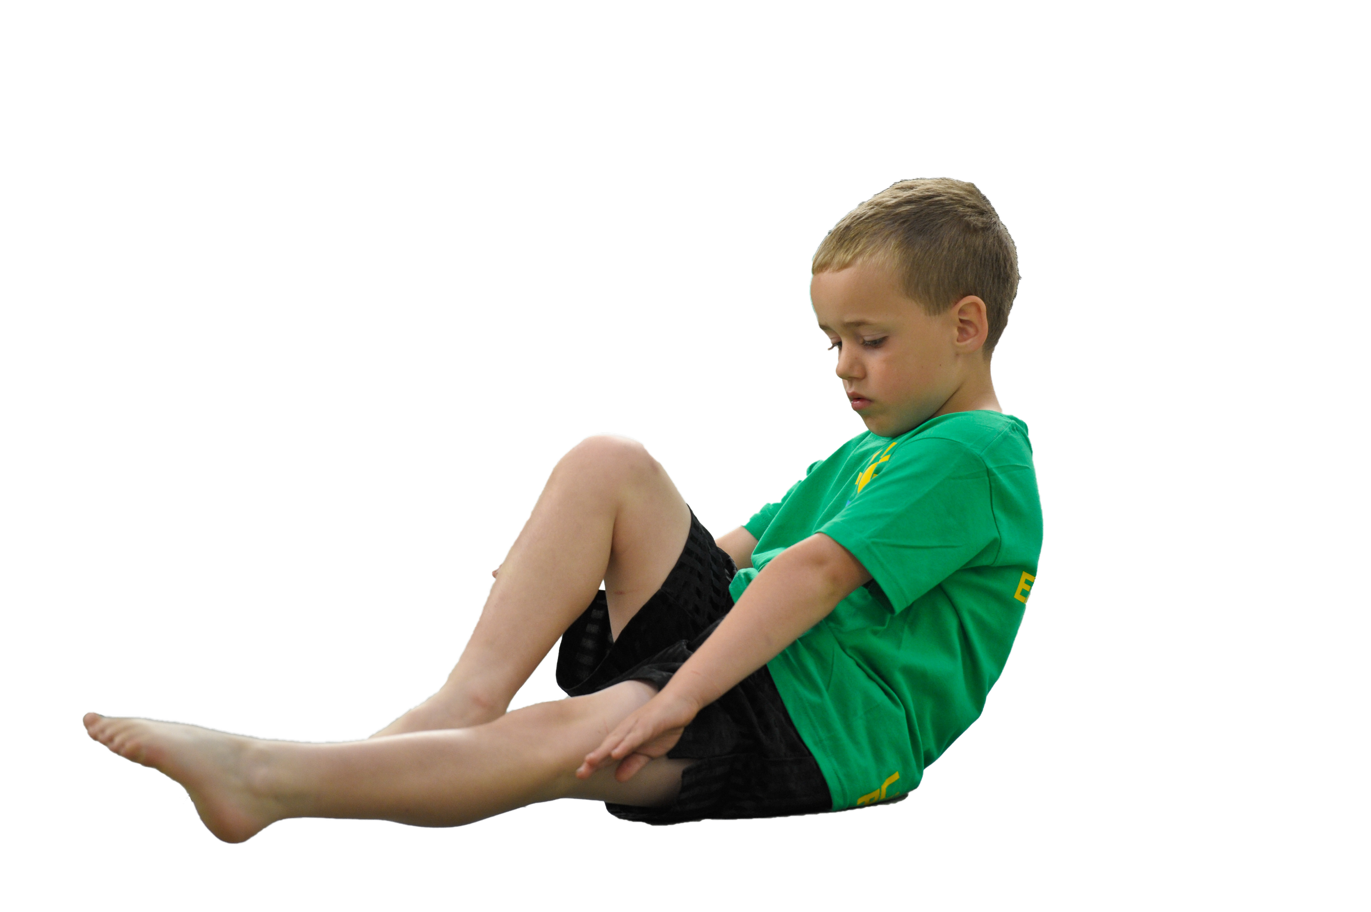
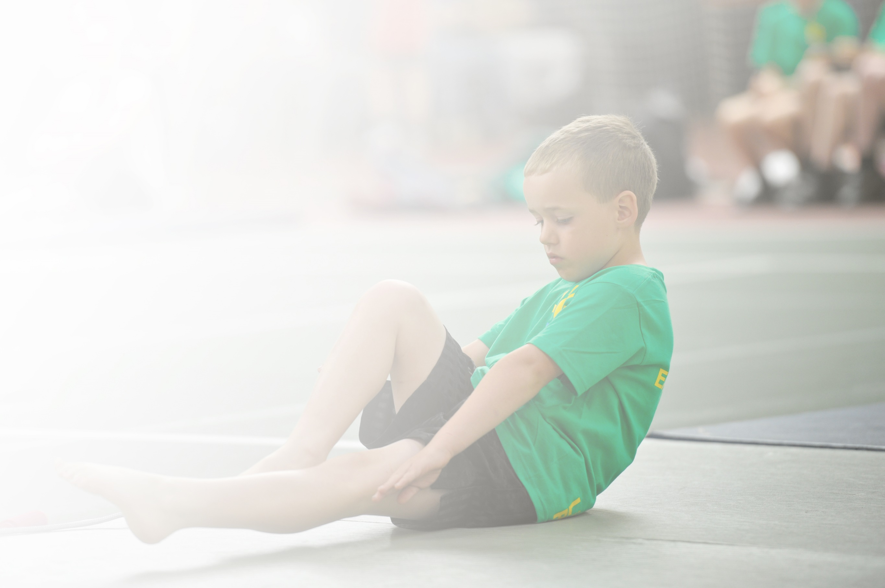
Schools must use the funding to make additional and sustainable improvements to the quality of Physical Education, Sport and Physical Activity (PESPA) they offer. This means that you should use the Primary PE and Sport Premium to:

- Develop or add to the PESPA activities that your school already offer
- Build capacity and capability within the school to ensure that improvements made now will benefit pupils joining the school in future years

Please visit gov.uk for the revised DfE guidance including the 5 key indicators across which schools should demonstrate an improvement. This document will help you to review your provision and to report
your spend. DfE encourages schools to use this template as an effective way of meeting the reporting requirements of the Primary PE and Sport Premium.

We recommend you start by reflecting on the impact of current provision and reviewing the previous
spend. Under the Ofsted Schools Inspection Framework, inspectors will assess how effectively leaders use the Primary PE and Sport Premium and measure its impact on outcomes for pupils, and how effectively governors hold them to account for this.

Schools are required to publish details of how they spend this funding as well as on the impact it has on pupils’ PE and sport participation and attainment by the end of the summer term or by 31 July 2019 at the
latest.
We recommend regularly updating the table and publishing it
on your website throughout the year, as evidence of your
ongoing review into how you are using the money to
secure maximum, sustainable impact. To see an
example of how to complete the table please
click HERE.

Support for review and reflection - considering the 5 key indicators from DfE, what development needs are a priority for your setting and your students now and why? Use the space below to reflect on previous spend, identify current need and priorities for the future.

Key achievements to date: | Areas for further improvement and baseline evidence of need:
Improved pupils’ participation in the School Games (Gold award received)  - Entered more cluster sport competitions (Inter-school)  - Provided sporting activities for children at our small, rural school.  - Raised the profile of sport and active lifestyle.  - Encourage leadership, timekeeping and officiating for KS2 pupils. | - Children more engaged in school sports, sports clubs are highly attended both after school and through link clubs.  - Children gain valuable opportunities to lead, manage and officiate sporting activities in a range of school sports.  - Need to focus on active travel to and from school and active teaching during class time (based on activity heat map self-evaluation review).
Introduced sports and activities to help pupils become more active for one off activity days or a series of high quality sessions  - Hired qualified coaches to work with teachers and pupils to extend sports provision and provide after school clubs for children including:  - Bikeability for year 6s.  - Circus York for all children in school.  - Chance to Shine cricket training for all children in school.  - York City Knights rugby based training for all children in school.  - JudoYork taster session for all children.  - Multi-sports club for KS2 and KS1. | - We will continue to provide a range of sports and sports coaches to work with teachers and pupils to benefit their health and wellbeing.
Development of school’s intra-school and inter-school competition programme  - Coaches for cluster sport events for KS1 and KS2 (10 events).  - TA cover to assist with transporting children to and from events.  - Part of the Easingwold cluster sports SLA (Thirsk SGO district). | - Increased physical activity ethos around school and expectations raised that school will send teams to inter-school events and participate in a full programme of sporting activity.  - Efficient tracking has been undertaken to ensure that all children get equal opportunities to participate in team and individual cluster sports.  - The competitions are an important part of school life and help to develop our school values of respect, compassion, friendship and perseverance.
Professional development in PE for staff to enable high quality PE to be taught in school  - CPD for staff (Early Years physical development)  - Teaching cover for staff training. | - Programme of training provided by North Yorkshire sport. Courses used to further PE provision and teaching in school.  - PE network meetings attended and opportunities for further CPD utilised through this.
Learning resources for high quality PE sessions  - Audio visual equipment bought to provide a full working music and projector system for PE lessons. Particularly used for dance, Zumba, physical development in early years, music and movement activities.  - Ipads for recording and photographing sport in PE e.g. recording pupil’s sport techniques and analyse these to further their learning and development.  - Books purchased which promote a range of sports, active lifestyle and physical/mental wellbeing. | - The resources have transformed PE sessions with children being able to use the audio visual equipment to participate in different activities, encouraging rhythm, movement, balance, agility and coordination.
Dedicated sports coach and joint PE lead appointed to:  - Support teachers in the delivery of quality PE and a range of sports during school, at lunchtimes and after school.  - Increased support in PE lessons, assisting in teacher confidence and ability to deliver quality first PE lessons.  - Organise and run intra school competitions to help children develop their sporting skills and promote our school values of respect, compassion, friendship and perseverance.  - Be a role model for children in school and help empower them to drive for sporting success. | - Sports coach has been able to upskill school staff in a range of sports and multi-skills for physical development and good physical and mental wellbeing.  - Assisting in the organisation and management of inter-school and intra-school events to promote an active lifestyle and giving children the chance to take part in regular, competitive sports.  - Consider refining role further for next academic year with a greater commitment to leading PE throughout the school.

Meeting national curriculum requirements for swimming and water safety | Please complete all of the below:
What percentage of your current Year 6 cohort swim competently, confidently and proficiently over a distance of at least 25 metres?  N.B. Even though your children may swim in another year please report on their attainment on leaving  primary school. | Year 3 | 66%
 | Year 4 | 92%
 | Year 5 | 86%
 | Year 6 | 100%
What percentage of your current Year 6 cohort use a range of strokes effectively [for example, front crawl, backstroke and breaststroke]? | Year 3 | 66%
 | Year 4 | 92%
 | Year 5 | 86%
 | Year 6 | 100%
What percentage of your current Year 6 cohort perform safe self-rescue in different water-based situations? | Year 3 | 66%
 | Year 4 | 92%
 | Year 5 | 80%
 | Year 6 | 100%
Schools can choose to use the Primary PE and Sport Premium to provide additional provision for swimming but this must be for activity over and above the national curriculum requirements. Have you used it in this way? | No.
Action Plan and Budget Tracking
Capture your intended annual spend against the 5 key indicators. Clarify the success criteria and evidence of impact that you intend to measure to evaluate for students today and for the future.

Academic Year: 2018/19 |  | Total fund allocated: £16,670 |  | Date Updated: Summer 2019
Key indicator 1: The engagement of all pupils in regular physical activity – Chief Medical Officer guidelines recommend that primary school children undertake at least 30 minutes of physical activity a day in school |  |  |  |  |  |  | Percentage of total allocation:
 |  |  |  |  |  |  | 23.8%
School focus with clarity on intended impact on pupils: |  | Actions to achieve: |  | Funding allocated: |  | Evidence and impact: | Sustainability and suggested next steps:
To increase physical activity throughout school for all children with the aim of providing at least 30 minutes of physical activity a day. |  | - Playground markings added to school playground to encourage physical activity and games at break time.  - Timetabled 2 hours of PE a week for all children in school.  - Purchased new playground and sporting equipment for all children to use in PE lessons and at break times. |  | £2000  £0  £1967 |  | Children have greatly enjoyed using the playground markings for sports matches as well as games at break times which encourage them to be physically active.  All classes are timetabled 2 hours of PE, checked by the PE lead to ensure they meet the minimum requirements of an active day. Forest school sessions and active learning in class ensures that 30 minutes minimum is met each day.  New equipment was chosen by the pupils who have used it during their PE lessons and also in their free time to maintain an active lifestyle. | Longer term for children:  - Increase physical activity to 60 minutes a day.  - Encourage more than 50% of children to attend a school sports club each week.  Longer term for staff:  - Increase daily physical activity through use of activity heat map self-evaluation tool and active English/maths courses for staff next year.  - Encourage the introduction of an active mile.  Next steps for the school:  - Book teachers on courses for next academic year.  - Decide on where to fit more activity into the daily school timetable and how to staff this.
Key indicator 2: The profile of PESSPA being raised across the school as a tool for whole school improvement |  |  |  |  |  |  | Percentage of total allocation:
 |  |  |  |  |  |  | 18.5%
School focus with clarity on intended impact on pupils: |  | Actions to achieve: |  | Funding allocated: |  | Evidence and impact: | Sustainability and suggested next steps:
To ensure that PE lessons, physical activity and wellbeing are of high quality and that they are taught effectively as a core subject that is timetabled for maximum engagement with pupils. |  | - Hiring of a sports coach to support teachers in the delivery of quality PE and a range of sports during school, at lunchtimes and after school.  - Forest School sessions taking place regularly across school by our accredited Forest Schools Leader  - The school held a mental wellbeing day with a big focus on how physical and mental wellbeing can affect our health. An active lifestyle was promoted to all children across the day.  - PE and sports books bought to promote healthy physical and mental lifestyles. |  | £3000  £0  £0  £80 |  | Our sports coach has provided a great standard of clubs and activities for children across school, assisting in training sports teams as well as helping staff with their lessons. He has assisted in giving Reception children extra sessions to improve their physical development.  Children have responded positively to Forest School sessions and have had ample opportunity to learn outdoors and improve both their physical and mental wellbeing.  A big, positive response from the children and parents. We will continue to do this event on an annual basis.  These have been used by teachers and pupils to promote healthy lifestyles across school, particularly in KS1 where pictures convey an age appropriate message clearly. | Longer term for children:  - To gain feedback from children about the PE sessions they want to see in school plus any feedback into what they think about PE.  - To continue to hold Forest School sessions, mental health and wellbeing days to engage all students in having an active lifestyle, raising the profile of PE in the process.  Longer term for staff:  - Ensure that all staff are confident in delivering PE following the newly implemented whole school PE scheme.  - Continue to review the effectiveness of this scheme in an annual basis.  Next steps for the school:  - To review PE provision currently in place including lessons, PE scheme and children’s attitude to PE.
Key indicator 3: Increased confidence, knowledge and skills of all staff in teaching PE and sport |  |  |  |  |  |  |  | Percentage of total allocation:
 |  |  |  |  |  |  |  | 25.4%
School focus with clarity on intended  impact on pupils: | Actions to achieve: |  | Funding  allocated: |  | Evidence and impact: |  |  | Sustainability and suggested  next steps:
The implementation of whole school PE curriculum along with progression documents for individual sports to assist with planning, delivery, assessment and continued quality. This will support staff in delivering a high standard of PE sessions for all. This will be accompanied by CPD for teachers who require additional assistance. | - Hiring of a sports coach to support teachers in the delivery of quality PE  - PE CPD “PE in the Early Years Foundation Stage”  - PE network meetings attended by PE lead to gain insight and new information about sports programmes in the county as well as further access to PE training and opportunities.  - Ipads for recording and photographing sport in PE e.g. recording pupil’s sport techniques and analyse these to further their learning and development.  - Whole school PE plan created and put in place by PE lead with a variety of indoor and outdoor provision as well as sport progression documents for all to use. |  | See key indicator 2.  £230  £0  £1000  £0 |  | Our sports coach has been able to work well with staff to support them in PE lessons and sports coaching.  The Early Years team has benefitted from the training programme and with support from our sports coach, they have been able to provide extra sessions of high quality physical development to all reception children.  PE lead has benefitted from networking at these meetings and has gained new skills and knowledge to share with whole school staff.  These resources have been essential in assisting teachers with delivering high quality PE and allowing both teachers and pupils to review their techniques as well as monitor their performance during competitive sport.  These whole school plans ensure that children build on skills across their school lifetime and become able sportsmen and sportswoman. It also helps teacher to deliver excellent PE sessions which develop key skills and good sporting techniques across all ages. |  |  | Longer term for children:  - To keep providing high quality PE sessions that are inclusive for all children.  Longer term for staff:  - To provide CPD to assist with subject knowledge and delivery of PE curriculum.  - To continue to attend PE network meetings and further enhance subject knowledge of PE and sports curriculum.  Next steps for the school:  - For SLT to support PE leads in refining PE curriculum.  - Continued PE CPD for all teachers and TAs.
Key indicator 4: Broader experience of a range of sports and activities offered to all pupils |  |  |  |  |  |  |  | Percentage of total allocation:
 |  |  |  |  |  |  |  | 27.6%
School focus with clarity on intended  impact on pupils: | Actions to achieve: |  | Funding  allocated: |  | Evidence and impact: |  |  | Sustainability and suggested  next steps:
Develop a range of sporting opportunities for all children through sports taster days, sports coaching in school, after school activities and physical activity equipment.  Aim to have at least 3 outside providers working with the children to encourage sporting participation and active lifestyle. | 1) Hired qualified coaches to work with teachers and pupils to extend sports provision and provide after school clubs for children including:  - Circus York for all children in school.  - Chance to Shine Cricket training for all children in school.  - York City Knights rugby based training for all children in school.  - JudoYork taster session for all children.  2) Bikeability safe bike riding skills for year 6s.  3) Multi-sports club for KS2 and KS1 (including multi-skills, cricket, archery, table tennis and netball).  - Residential adventurous outdoor activities for some pupils in year 5  - Audio visual equipment bought to provide a full working music and projector system for PE lessons. |  | £150  £300  £260  £0  £560  £0  £700  £2623 |  | Excellent feedback from children and parents due to wide range of sports provided. Children in large numbers have been taking up new sports and becoming more active individuals as a result of this.  Chance to Shine Cricket was particularly well received and school became a case study for the programme.  All year 6s passed the training and instructors were impressed with their dedication and attitude.  Our dedicated sports coach ensured that a good range of sporting activities were on offer that children enjoyed, with the after school club being oversubscribed.  Children had the opportunity to access a range of outdoor activities including rock climbing, archery, canoeing and orienteering. This raised self-esteem and self-confidence in the children involved.  Particularly used for dance, Zumba, physical development in early years, music and movement activities. This has increased the number and range of opportunities we can provide to all our school children. |  |  | Longer term for children:  - Continue to expose children to a wide range of sports and activities.  - Develop an active travel programme promoting safe and active travel skills to and from school.  - Ongoing access to cluster sport competitions, training for team sports and developing sports leaders in KS2.  Longer term for staff:  - Continued professional development through sports coaches supporting and leading PE sessions.  Next steps for the school:  - A full and representative pupil voice to be collected about the provision, sports and external providers they would be interested in having in school.
Key indicator 5: Increased participation in competitive sport |  |  |  |  |  |  |  | Percentage of total allocation:
 |  |  |  |  |  |  |  | 22.8%
School focus with clarity on intended  impact on pupils: | Actions to achieve: |  | Funding  allocated: |  | Evidence and impact: |  |  | Sustainability and suggested  next steps:
All KS2 children to take part in at least 2 competitive school events across the academic year at inter-school level. KS1 to take part in at least 1 event at inter-school level. Intra-school sports events will be increased this year to at least 4 per key stage by summer 2019. | - Expanded participation in cluster sports programme of events across the school year (Easingwold cluster, Thirsk SGO district).  - Increased lunchtime and after school clubs.  - Increased school intra-school events (5 per year minimum) |  | £3800  £0  £0 |  | Children have had the opportunity to go to 10 different cluster events (8 KS2, 2 KS1) and have performed well , raising the profile of PE in school and encouraging healthy, active competition amongst their peers.  Children have been attending clubs in good numbers with over 50% of children in KS2 attending an after school sports club.  Intra-school events or house vs house events have been popular and have presented all children with the opportunity to compete against their peers at a school level. |  |  | Longer term for children:  - Access to cluster competitions at level 1, 2 and 3 were appropriate.  - More opportunities to compete in houses across the school year.  Longer term for staff:  - Ensuring that all staff have the opportunity to organise and support the coordination of intra and inter school sporting events throughout the year.  Next steps for school:  - Consider how KS1 have can have access to a similar broad range of cluster sports as KS2 have.  - Increase number of intra school events each year by 20%

