Be friendly.  Make a new friend or get to know someone better by asking them to play  This Photo by Unknown Author is licensed under CC BY | Play a game together.  Take turns and follow the rules.  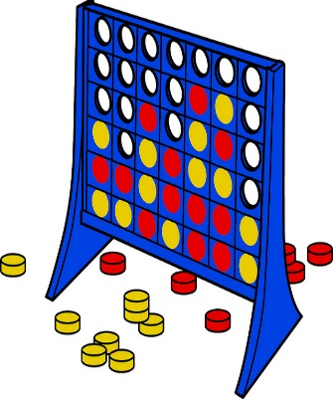 | Go on an Autumn walk. Look for seasonal changes. Collect conkers,pine cones, beechnuts. Count how many you have found. | Practice a nursery rhyme that you enjoy. Perform it to your family and then to your classmates at school.
Be a master of disguise and create a superhero mask. | Find out about a real life hero and their achievements. Y1’s could write a few sentences about their hero. | Practice fastening and unfastening coat zips and buttons and putting on wellies ready for playing outside.  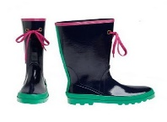 | Look at photos and talk about memories and milestones and important events in your child’s lifetime and create a time line.
Look for different plants and animals in our environment. Can your child find and identify birds, plants and animals?  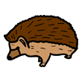 | Be active- ride a bike, trike or scooter. | Learn to set the table for tea. Count how many of each things you need and put them in the correct places for your family.  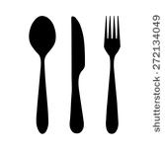 | Watch a film with a hero character and talk about the storyline. What qualities does the hero have?

