Year 4/5/6 Homework Autumn Term (1st half)

Please complete one activity from the grid below each week.
Items shaded in purple are compulsory tasks. You may choose from the white tasks for the remaining weeks of the half term.
In addition to the homework tasks, the following ongoing activities should be undertaken each week:
- Spelling practice
- Independent reading (recorded in reading diaries): Year 4 – 15-20 mins daily; Year 5 20-25 mins daily; Year 6 25-30 mins daily.
- Multiplication tables
Write a review of a film you have enjoyed.    To be completed by 28th September. | Music    Make up a jingle for a new chocolate product. If you can, record it or perform it to your class. | Reading Comprehension    Complete the reading comprehension on Fairtrade (Sheet provided)  To be completed by 12th October
Collect conkers and play the traditional game of conkers (Taken from the National Trust’s 50 Things to Do Before you are 11³_{/4})  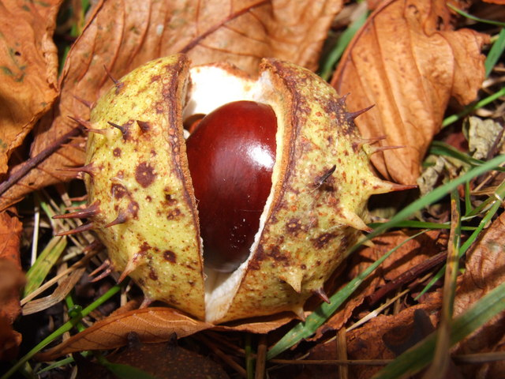 | Family Activity  Go on a walk and look for the first signs of autumn (e.g. berries, leaf colour…)    How can you record what you saw? Observational drawings? Poetry? Photos? Something else?  You choose! | Bake a treat which includes chocolate as one of the ingredients.  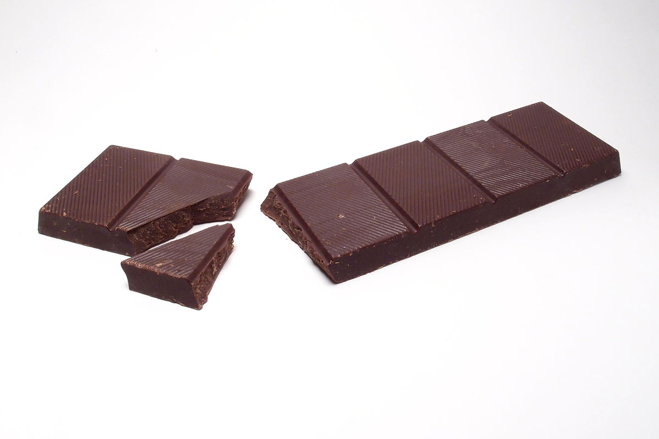  Feel free to bring in a sample!
Mathletics    Practise your maths skills by completing as many tasks as you can on Mathletics.  What is the highest certificate you can earn?  Ongoing task | Design an advertising poster for a chocolate product of your choice. This could be for a real product or for one you have made up.   | See how many different types of Fairtrade products you can find at the supermarket.    Think about how you could categorise them and present your findings.  Venn diagram? A graph? Something else?  To be completed by 19th October

