Year 2/3 Autumn term 1 (until half term)
Weekly activities: Reading each day, spelling activities, choose one activity from the grid
Maths – Katie Morag  Katie Morag needs some help at the post office! Find 5 different items, estimate how much they weigh and then weigh them to see how close your estimate was.  Bonus – You could also use the Royal Mail website to work out how much money it would cost to send each item in the post.  To be completed by 22/09/17 | 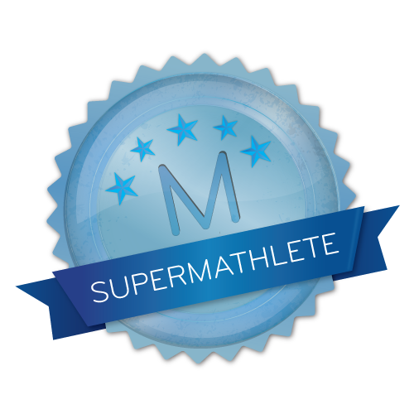  Complete Mathletics activities and games to get certificates! Miss Hodkin will set some each week to do and we will celebrate these during celebration assembly.  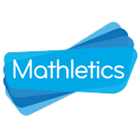 | Topic - Scotland  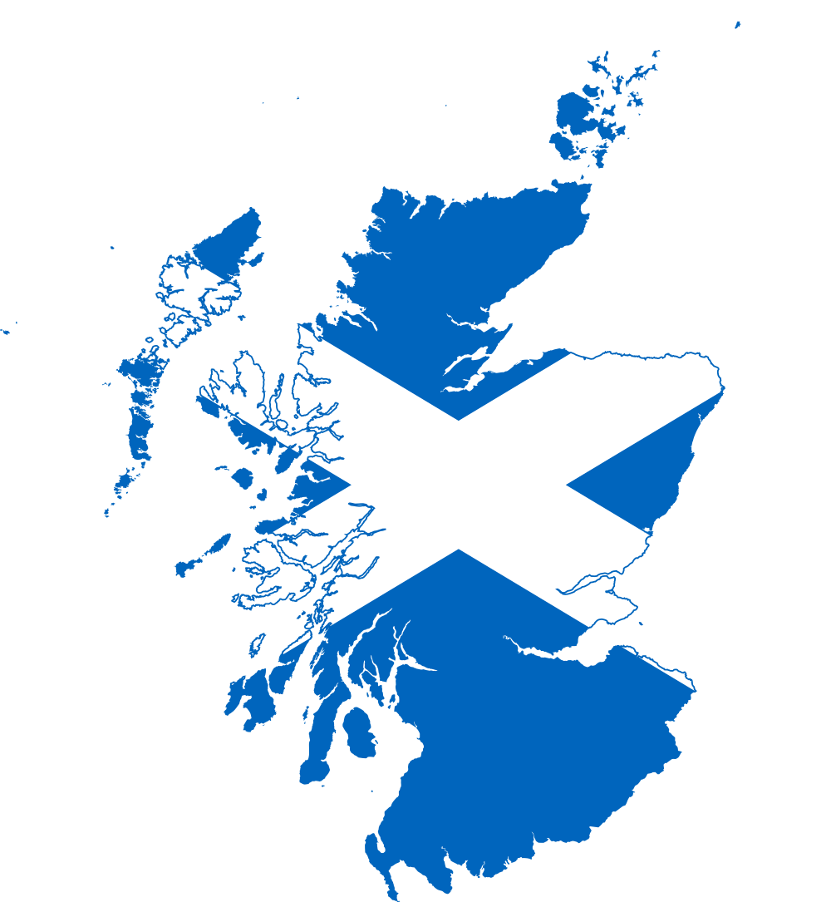  Research a town or city in Scotland and create a fact file for it. Remember to include pictures and lots of interesting facts!  To be completed by 29/09/17
Highland games!  Design a new event for the Highland Games! It could include be based on traditional Scottish events or could be something you really enjoy doing. Make sure the event has a set of rules or instructions for how to compete. | Family Activity - coasts  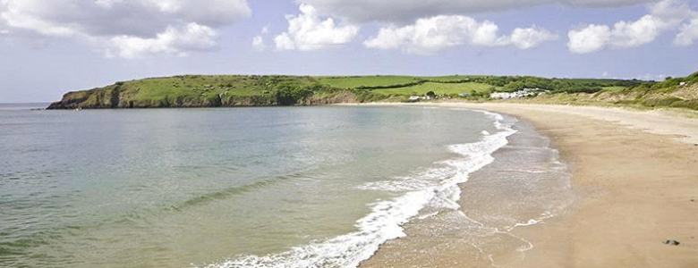  Take a trip to the coast/beach and either draw or take photos of all the things you spot during your trip. Bonus points if you spot any island features whilst you are there! | Geography – Islands  Create your own island, either by drawing and labelling a picture or you could even make a 3D model one! Make sure you label all the features of an island and give your island a name.  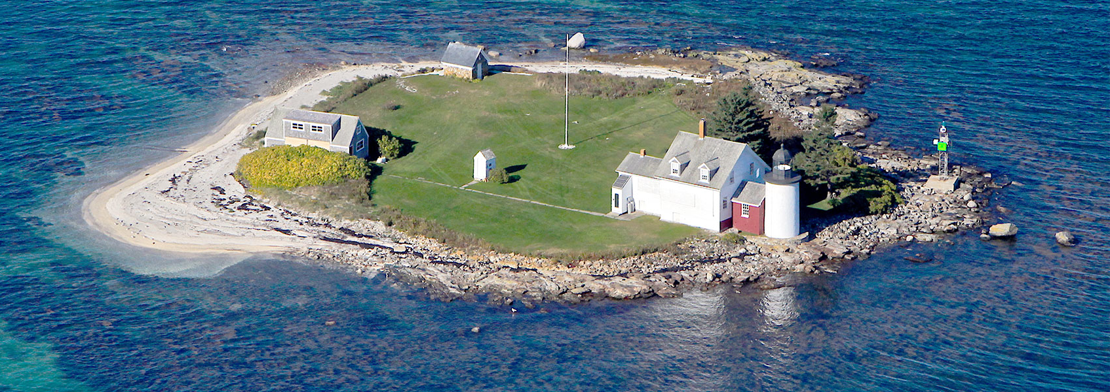
Science - Materials  Choose one of the objects in your house. What material is it made from? Can you explain why you think this material has been chosen to make it? E.g. My toy box is made of wood because it is strong. It needs to be strong to hold lots of toys! You can do more than one idea…..  To be completed by 6/10/17 | Catch some falling leaves or make some wild art with leaves and sticks  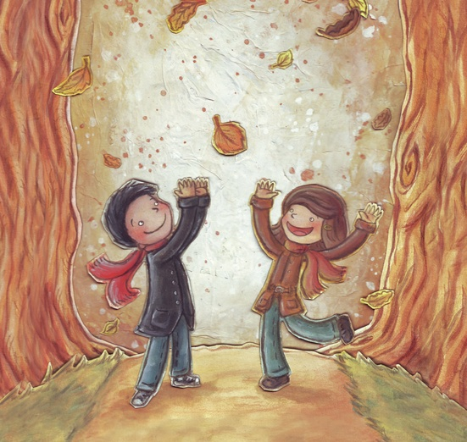  (Don’t forget to take  pictures).  (Taken from 50 things to do  before you're 11¾ National Trust). | Literacy – Book review  Write a book review of the best book you have read this term. It can be one you have read at home or one we have read together in class. Make sure you write about what the book was about, what you liked about it and why other people should read it.  To be completed by 13/10/17

