Sutton on the Forest Church of England
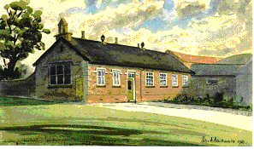
Voluntary Controlled Primary School
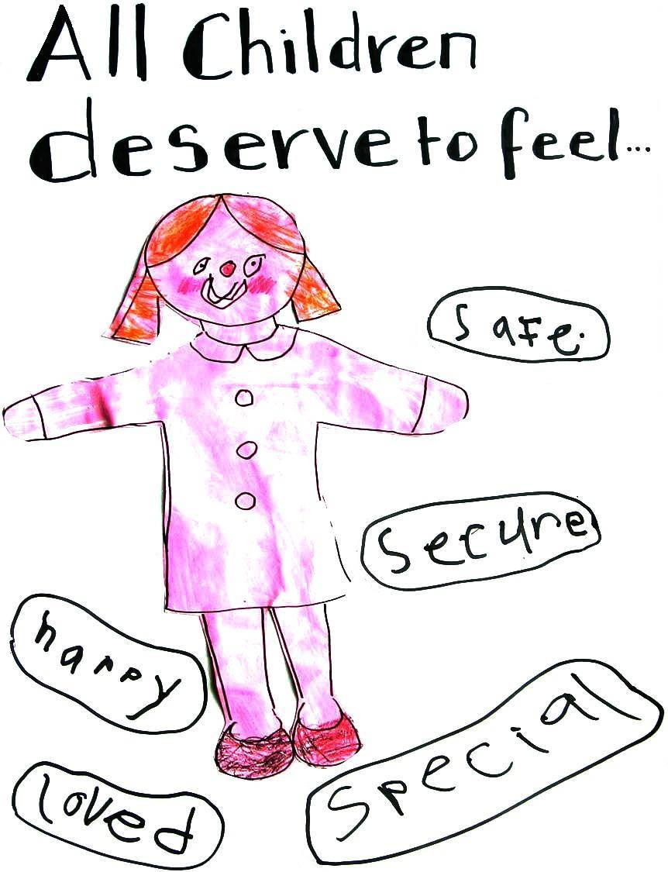
Main Street
Sutton on the Forest
York YO61 1DW
Tel No: (01347) 810230 Fax No: (01347) 811528
E mail: admin@sutton-on-the-forest.n-yorks.sch.uk
Web: www. sutton-on-the-forest.n-yorks.sch.uk
To create a school where we all:
Go further than we thought,
run faster than we hoped,
reach higher than we dreamed,
to become the people God meant us to be.....

6th September 2016

CONSENT FOR USE OF PHOTOGRAPHS ON THE SCHOOL WEBSITE

Dear Parents,

We frequently add images to the school website of children taking part in class activities. To enable us to post pictures of your child, we would to like to seek your permission. I would be most grateful if you could return this form to the school office as a matter of urgency so that staff can keep the website up-to- date.

If you are a new parent to the school or unfamiliar with the website it can be found at www.sutton-on-the-forest.n-yorks.sch.uk it is very useful source of information including copies of letters and newsletters sent home, school policies and images of activities undertaken by children in school.

JL Botham
Headteacher

…………………………………………………………………
I give consent/do not give consent for photographs of my child to be posted on the school website (please circle your answer)

Child’s name………………………………………………………………

Signature of parent of guardian ……………………………….Date………

